**HR Analytics Dashboard Using Power BI**

**1. Project Overview**

The **HR Analytics Dashboard** is a powerful tool designed to analyse employee attrition patterns and provide actionable insights for improving workforce retention. Using **Power BI** for visualization and **Excel** for data preprocessing, the dashboard enables HR managers to identify key trends and develop strategies to optimize workforce management.

**2. Objectives**

* Understand and analyse factors influencing employee attrition.
* Provide data-driven insights to reduce turnover and enhance employee satisfaction.
* Support HR decision-making with interactive dashboards and key performance indicators (KPIs).

**3. Technologies Used**

* **Power BI**: For creating interactive and visually appealing dashboards.
* **Excel**: Used for initial data cleaning and transformation.

**4. Dataset Description**

The dataset comprises 1,470 rows and 38 attributes, capturing various aspects of employee information, such as demographics, job satisfaction, performance metrics, and attrition. Key attributes include:

* **Attrition**: Indicates whether an employee has left the organization.
* **Age, Gender, and Marital Status**: Demographic information for workforce analysis.
* **Job Role and Department**: Details about the employee's position and organizational function.
* **Business Travel**: Frequency of work-related travel.
* **Satisfaction Ratings**: Metrics for job satisfaction, environment satisfaction, and work-life balance.
* **Years at Company**: Tenure with the organization.
* **Monthly Income**: Employee compensation.

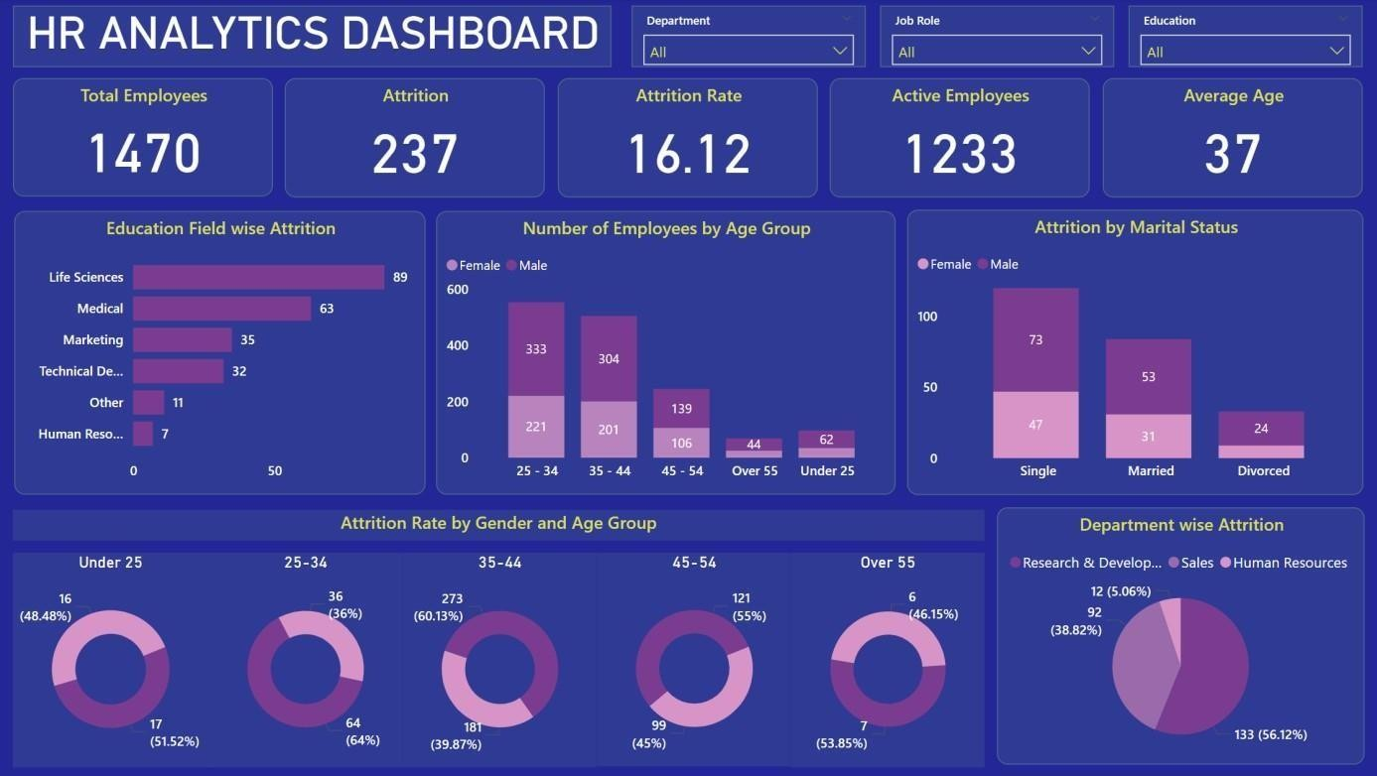**5.Dashboard Overview:  
The dashboard is structured into two main pages, each addressing specific aspects of employee data:**

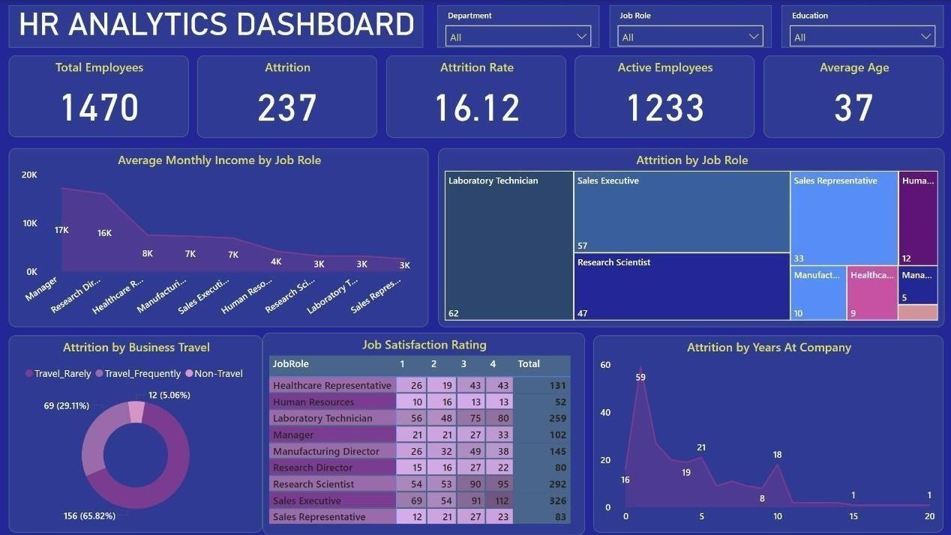

**6. Dashboard Highlights**

The dashboard is divided into two primary sections:

**Page 1 - General Overview and Demographics**

* **KPIs**:
  + Total Employees: 1,470
  + Active Employees: 1,233
  + Attrition Count: 237 (16.12% attrition rate)
  + Average Age: 37 years
* **Key Insights**:
  + Life Sciences has the highest attrition among education fields.
  + Younger employees (aged 25–34) represent the largest group with high attrition.
  + Research & Development experiences the highest departmental attrition (56.12%).

**Page 2 - Job Roles, Business Travel, and Satisfaction**

* **Income and Role Analysis**:
  + Managers earn the most, while Sales Representatives have the lowest average monthly income.
  + Laboratory Technicians and Sales Executives have the highest attrition rates.
* **Satisfaction and Business Travel**:
  + Employees traveling rarely show the highest attrition (65.82%).
  + Low job satisfaction correlates strongly with attrition.

**7. Key Insights**

1. **Demographics**:
   * Younger employees (<25 years) are more likely to leave.
   * Single employees face higher attrition compared to married or divorced employees.
2. **Departmental Trends**:
   * Research & Development needs targeted retention strategies due to its high turnover.
   * Human Resources exhibits low attrition and can serve as a benchmark.
3. **Role and Income**:
   * Lower-income roles experience more attrition.
   * Higher-paid employees, such as Managers, are more likely to stay.
4. **Satisfaction and Travel**:
   * Low satisfaction ratings are strongly linked to higher turnover.
   * Frequent business travel contributes moderately to attrition.

**8. Recommendations:  
To address the identified challenges and improve workforce retention:**

* **Targeted Onboarding Programs: Enhance support for new hires through structured mentoring and integration plans.**
* **Tailored Retention Strategies: Focus efforts on departments with high attrition, such as Research & Development, using HR benchmarks for comparison.**
* **Job Satisfaction Improvement: Conduct regular surveys and address concerns to boost engagement, particularly for roles with high dissatisfaction.**
* **Work-Life Balance Initiatives: Implement policies to mitigate travel fatigue and offer flexible working arrangements.**
* **Compensation Review: Adjust salaries for lower-paid roles, such as Sales Representatives and Laboratory Technicians, to align with industry standards.**

**9. Conclusion**

The **HR Analytics Dashboard** serves as a comprehensive tool for understanding and addressing employee attrition. By leveraging insights from this analysis, organizations can develop targeted strategies to improve retention, enhance employee satisfaction, and ultimately drive organizational performance. With the integration of advanced analytics and visualization, the dashboard empowers HR teams to make data-driven decisions, reduce turnover costs, and build a more resilient workforce.